***Lighthouse***

Kurt Newcomb

CST-451 Capstone Project Proposal

Grand Canyon University

Instructor: Professor Amr Elchouemi

Revision: 1.0

Date: 8/21/2022

**ABSTRACT**

Summarize the entire project in 2-3 paragraphs, about 15-20 lines. The abstract should be enough for one to get an idea of what this project is about, what was the task, and what you accomplished. Briefly provide the broader context. Write this section only after the entire project is complete.

|  |
| --- |
| History and Signoff Sheet |

**Change Record**

|  |  |  |
| --- | --- | --- |
| **Date** | **Author** | **Revision Notes** |
| 8/21/2022 | Kurt Newcomb | Initial draft for review/discussion |
|  |  |  |
|  |  |  |

|  |
| --- |
| **Overall Instructor Feedback/Comments** |

|  |
| --- |
| **Overall Instructor Feedback/Comments** |

**Integrated Instructor Feedback into Project Documentation**

Yes  No

**Project Approval**

Professor Amr Elchouemi

Project Overview and Project Objectives

**State the Problem and Background**

Many people out there in the world are dealing with lots of emotional trauma and the stress that comes with it. I myself don’t struggle with this as much as several people I care about, so I felt like I wanted to help in some way. As it happens, and as best as I can observe, many of my loved one’s stress and trauma stems from the lack of communication, not moving on from the trauma, and overall struggling to communicate their feelings to let go and move on. This led me to the conclusion that many introverts might struggle with emotional issues like the loved ones I mentioned earlier. I thought to myself, what can I do to help an introvert talk to someone to help relieve the stress. Well, one of the main deterrents is talking to someone else, then I need to give them a tool that helps them talk with themselves at the least, and maybe that will help them take the next step of talking to someone else more easily. Another problem is that emotions can be overwhelming, and that led me to thinking that something that could help would be something that makes the process so simple that you can’t help but not doing it. So, that gave me the idea to provide someone who is feeling overwhelming emotions a decision tree type application that helps the process what they are feeling in a constructive and concrete way. So, if someone is mad, they could open up the app, and journal how they are feeling at the time, what is making them feel that way, and whatever other important information they feel is relevant. Hopefully, after writing everything down, it will help them overcome the stress, maybe slowly or quickly, it doesn’t matter as long as it helps them make progress. Which gave me the idea for the next part of the application, a timeline that shows them all their journal entries, so they can see how much progress they have made in terms of being able to handle their emotions.

**Christian Worldview**

For my non-Christian final project, I would have chosen to develop a game based on an old trading card game called Chaotic, which went out of business, but it was really fun and I miss playing it, so at some point I’d like to remake it. With that being said, building a whole game would be a massive undertaking for an 8-week project and I came up with what I believe is a much better idea that also happens to do better for the world, which is the emotional support system noted above. Obviously, I could do something that is more interesting to me personally, but it does much less good for the people who really need it. The idea is to help the people who can’t help themselves, and since people who struggle with emotional control are being overwhelmed by emotions, they don’t have the techniques and skills to handle them, then I want to give them a tool that can help them.

**Project Objectives**

* Create a feature that allows a user to answer prompts about their current emotional state.
* Create a feature that allows the user to look back at their old journal entries.
* Create a feature that allows a user to create an affirmation for themselves
* Create a feature that pushes notifications to the user’s phone to remind them of their affirmations
* If all of the features are implemented and working correctly, then all that’s left is to have a user test the application for usability and appreciation.

**Challenges**

As previously noted in the Halo portal, the first issue that I will possibly have could be, the lack of experience with Android Studio. Not being familiar with the IDE or mobile app development in general means I basically have to start from scratch in terms of development.

The second big challenge will be my work schedule. Normally, I work Sundays-Tuesdays plus every other Wednesday from 3am-3pm. With that being said, I normally get home between 4-4:30pm, so by the time I finish up eating dinner and preparing for the next work day, it’s pretty much time to hit the sack. This means that normally, most of my schoolwork time is restricted non-working days. On top of that, work has been calling for mandatory overtime on my off-days.

Another challenge that reared its ugly head hit me at the end of my last class, but has since taken a backseat, is technical difficulties around the house. Normally, we take good care of our technology and equipment, which is why we’ve had lots of them for far longer than most people do, such as phones, televisions, cars, etc. Due to that fact, currently we seem to be experiencing a lot more failure trouble with technology like our computers and cars. Our internet has also been on the fritz lately for some reason, and it just happens to randomly fix itself after a while.

Life, while fairly simple most of the time, has seemingly ramped up the unfortunate series of events over the past few months. Like, when my household somehow wound up with two rambunctious unruly dogs, one of which is a puppy, meaning it peeps and poops in the house, which of course cleaning up chews into my work time. Obviously, everyone has their own problems in life, and I’m not trying to excuse anything, just thinking out loud to really illustrate why I think this project idea is the exact right project for me.

**Benefits and Opportunities**

Describe the benefits or opportunities resulting from project implementation.

Provide references as necessary.

Benefits:

* Lessen emotional stress for users
* Improve the quality of life and overall emotional strength of users

Opportunities:

* Practice mobile application development
* Create an application that actually helps people close to me, and others like

Project Scope

1. Give a clear, concise statement that states the scope of the project. This should also include items that are to be out of scope.

The scope of the project is pretty focused. The idea is to create a mobile application that is a tool for users who suffer from stress and emotional trauma that helps them work through the overwhelming feelings that give them a hard time.

1. Use the template to list all known stakeholders and contacts, if applicable, including self (for some projects self may be the only name listed)

|  |  |  |
| --- | --- | --- |
| Stakeholder Name | Role(s) | Responsibilities |
| Kurt Newcomb | Developer | Application/Documentation Creation |
|  |  |  |

1. List the work breakdown required to satisfy the project objectives. Identify teams and other resources that may be required to successfully complete the project.

|  |  |  |  |  |  |  |  |  |  |  |
| --- | --- | --- | --- | --- | --- | --- | --- | --- | --- | --- |
| Work Breakdown Structure | | | | | | | | | | |
| ID | Task | Dependencies | Status | Effort Hours | Cost | Start Date | Planned Completion | Estimate to Completion | Actual Completion | Resource |
| 1 | Create journal entry feature | None | Incomplete | Many | None | 8/21/2022 | 9/11/2022 |  |  |  |
| 2 | Create timeline feature | #1 | Incomplete | Lots | None | 8/21/2022 | 9/11/2022 |  |  |  |
| 3 | Creature affirmation feature | None | Incomplete | Many | None | 8/21/2022 | 9/11/2022 |  |  |  |
| 4 | Create notification push feature | #3 | Incomplete | Lots | None | 8/21/2022 | 9/11/2022 |  |  |  |

(Note: I am really bad at judging how many hours things will take, especially at this point in my development career)

Project Success Measures

1. Describe what measures will be used to calculate project success.

I will consider the project a success if I can make all intended feature work, create a reasonably appealing user interface, and if any of my test subjects tell me that it’s something they could see themselves or someone else with similar issues using to help overcome their emotional stress.

1. Use the template to list the project completion criteria.

|  |
| --- |
| Project Completion Criteria |
| 1 – Journal Feature |
| 2 – Timeline Feature |
| 3 – Affirmation Feature |
| 4 – Notification Feature |

1. Use the template to list the project assumptions and constraints, if applicable. An assumption is an educated guess that a likely condition or circumstance is presumed to be true. A constraint is a limiting condition or circumstance that defines the project boundaries. Assumptions allow the project to succeed. Constraints restrict or limit the project execution.

|  |  |  |  |  |  |
| --- | --- | --- | --- | --- | --- |
| Assumptions and Constraints | | | | | |
| ID | Description | Comments | Type | Status | Date Entered |
| 1 | Mandatory overtime at work | Hopefully I can get out of it | Constraint | Good | 8/20/2022 |
| 2 | Technology issues | The issues are fairly consistent in their randomness, so I firmly believe something will go wrong over the course of the class, but hopefully it won’t be a big deal. | Assumption | Good | 8/20/2022 |

Project High-Level Solution

**Introduction**

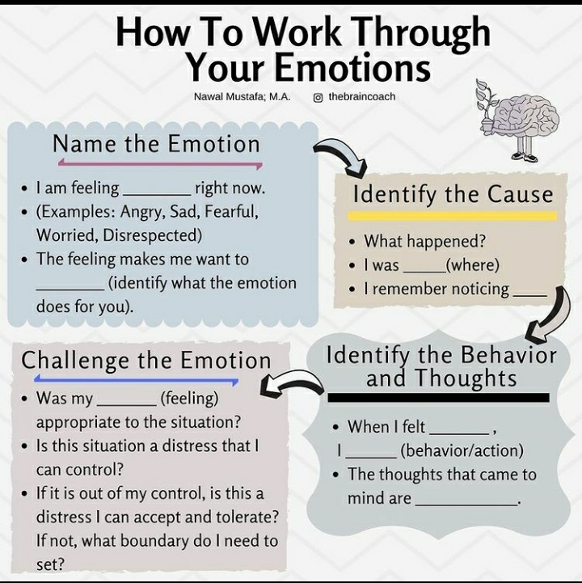The challenge I am trying to address with this project is the stress and mental trauma that comes with overwhelming emotions. The challenge that many introverted people seem to experience with overwhelming emotions is that they tend to internalize them, instead of processing them in a healthy way which exacerbates the problem in the long term. The goal of the project is to make create a digitize a process that allows an introvert to express their feelings outside of their own mind in a more concrete manner, which should help them process the emotion theoretically.

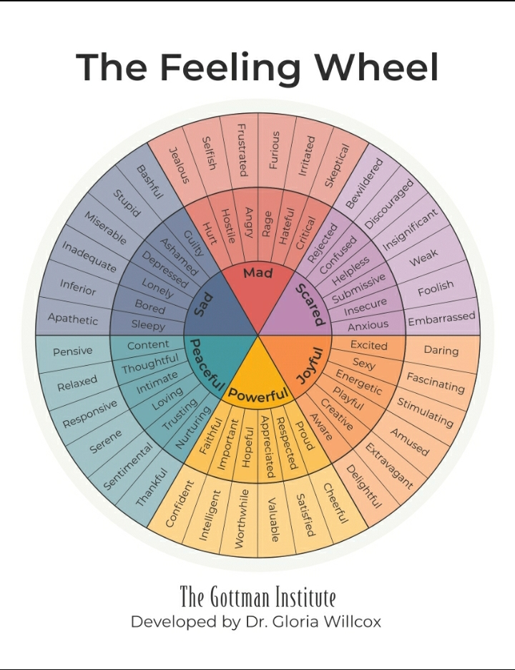Here is a diagram of a thought process that was sent to me as a recommendation for a good starting point:

Another aspect that I hope to include is a bit of prompted specification for the feelings themselves. When you ask someone how they are feeling and they give you a one-word answer, it generally means that haven’t put that much thought into why, which is part of the problem. I was then recommended to take a look at this chart, which is something I want to similarly include in my app in some way.

**Solution**

Describe in detail the nature of your solution, both in theoretical terms (principles, concepts) as well technical terms (UML, flowcharts, pseudocode, code snippets). If the project is entirely theoretical/mathematical, prove every point you make and anchor in external references. If the solution is code or another type of software, provide an architecture of the solution (diagram), clearly labeling and explaining the function and operation of each component. Detail the type of input, output, and the nature of data/information processing. Provide screenshots of correct execution of your code. Include key code snippets and comment on their role and approach to implementation. Detail and reference any external resources used. Summarize this section with a reminder of how your answer/approach/solution addresses the objectives.

Initial UML Diagrams

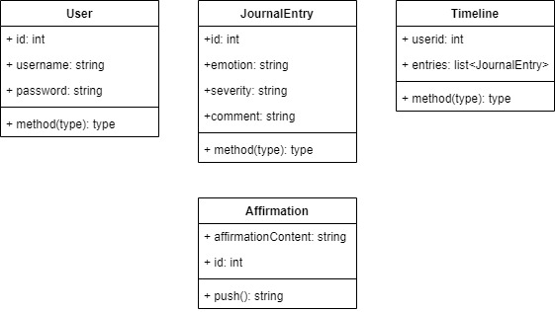

Initial Flowcharts  
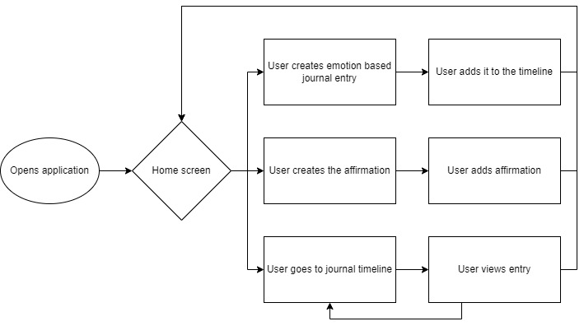

Wireframe Designs – Journal Entry

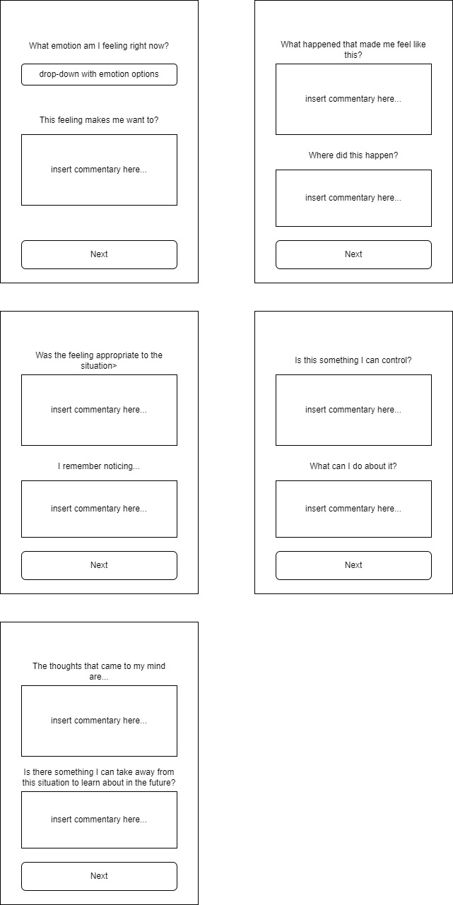

Wireframe Designs – Entry Timeline

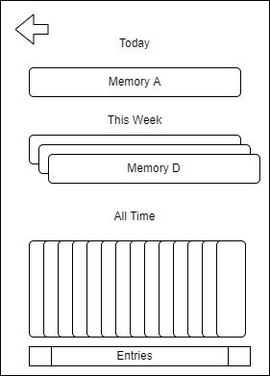

Project Controls

|  |  |  |  |  |
| --- | --- | --- | --- | --- |
| Risk Management | | | | |
|  | **Risk Probability** | **Risk Impact** |  |  |
| **Event Risk** | **(high, medium, low)** | **Risk Mitigation** | **Contingency Plan** |
| What is the risk? | What is the probability? | What is the impact if the risk occurs? | What can be done to minimize the risk? | What can be done to minimize the impact of the risk? |
| Technology failure | Low/Medium | Inability to produce work on time, or at all | Have a backup computer ready to go, utilize Github for code backup and access across multiple devices | Constant saving of work |
| Mandatory overtime at work | Medium/High | Chews into set aside worktime by potentially significant margins | Talk to supervisor about not being made to attend the overtime | Refuse to attend if it seems like I need the time and screw the consequences at work |

Appendix A – References

*List all references using APA style*

Appendix B – Copyright Compliance

For each external technical tool or code used, provide a reference to its copyright policy, clearly showing your right to use it. For each external technical tool or code used, detail how you used it, how you adapted it, how you modified it (if permitted), and why did you use it as opposed to write your own. Only a small portion of your project may rely on external code. When code libraries/packages are used, explain why this was necessary/required/recommended. Seek instructor approval for using external resources prior to beginning to work on the project.